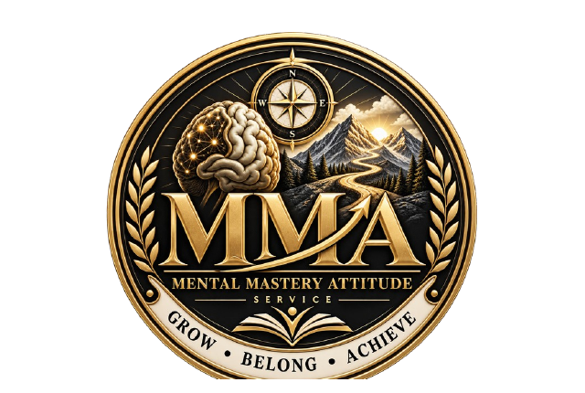

THE MENTAL MASTERY
MINI WORKBOOK
A practical guide to understanding and directing your mind
FREE GUIDE

Created by Anton Dwyer
Lived experience • Professional experience • Practical change

Welcome
What this guide will help you do
Your mind constantly notices, interprets and predicts. It turns experiences into thoughts, thoughts into feelings and feelings into urges. When this process runs automatically, an old belief or a strong emotion can direct your next move before you have properly considered the consequences.
Mental mastery does not mean controlling every thought or never feeling angry, anxious or discouraged. It means becoming aware of what is happening inside you, slowing the process down and choosing a response that supports the direction you want for your life.
The aim
By the end of this mini workbook, you will have identified one unhelpful mental pattern, challenged it and created a simple seven-day plan for directing your attention and actions more deliberately.
The main area of my life I want to improve is...

If I improved this area, the difference would be...

How the mind creates direction
A situation does not travel straight into an action. Your mind gives the situation meaning first. That meaning affects your emotion, your urge and the choice you make.
Stage | Question to ask
Situation | What happened, using only observable facts?
Thought | What did I tell myself it meant?
Emotion | What did I feel, and how strongly?
Urge | What did I immediately want to do?
Choice | What response best protects my future?
Result | Where will this choice lead if repeated?
Key principle
You may not control the first thought that appears, but you can learn to examine it before allowing it to choose your direction.
A recent situation where my first reaction took over was...

Your mental direction check
Think of attention as a steering wheel. Whatever receives repeated attention gains influence. Score each statement from 1 to 5, where 1 means rarely true and 5 means consistently true.
Statement | Score
I notice my thoughts before reacting. | ___ / 5
I can separate facts from assumptions. | ___ / 5
I can calm myself before making a choice. | ___ / 5
I focus on what I can influence. | ___ / 5
My daily actions match the future I want. | ___ / 5
My strongest area is...

The area that needs the most attention is...

One distraction, person or environment that often pulls me off course is...

Catch and challenge the thought
Use this exercise when a thought feels powerful, absolute or likely to push you towards a harmful or unhelpful response.
1 What happened? State the facts without adding meaning.

2 What automatic thought appeared?

3 What emotion and urge followed?

4 What evidence supports the thought?

5 What evidence or alternative explanation challenges it?

Choose a more useful direction
6 What is a more balanced and accurate thought?

7 What choice would protect my future, values and important relationships?

8 What could happen if I repeat the old reaction for six months?

9 What could improve if I repeat the new response for six months?

A useful question
Will this choice make tomorrow easier or harder?

The Pause Check Direct method
Pause
Interrupt the automatic reaction. Breathe slowly, step away if safe and allow the intensity to reduce. A pause is not weakness; it creates room for choice.
Check
Ask: What are the facts? What am I assuming? Am I reacting to the present situation or an older experience? What are the likely consequences?
Direct
Choose where to place your attention and what to do next. Direct yourself towards the action that supports safety, self-respect, progress and the person you want to become.
My warning signs that I am about to react are...

Three things that help me pause are...

A person I can contact before acting is...

A sentence I will tell myself in the moment is...

Seven day mental direction plan
Choose one mental habit to practise. Keep it small, specific and realistic. Record one example each day.
The thought or reaction I want to interrupt is...

The balanced thought I will practise is...

Day | Trigger | New direction | Done
1 |  |  | □
2 |  |  | □
3 |  |  | □
4 |  |  | □
5 |  |  | □
6 |  |  | □
7 |  |  | □

Review your progress
What did I notice about how my mind works?

Which thought did I challenge successfully?

Which choice did I handle differently?

What made the new response difficult?

What will I continue practising?

My next step
I will continue using Pause Check Direct when ________________________________.

Keep building mental mastery
This mini workbook is a starting point. Lasting change comes from repeating the skills: notice the pattern, check the meaning, calm the reaction and direct the next move.
Mental Mastery Attitude Service supports young people, parents, professionals and organisations through practical mindset, resilience, decision-making and behaviour-change education.
Remember
Your past may explain your thinking, but it does not have to determine your direction.
For workshops, mentoring, professional training or organisational enquiries, contact Mental Mastery Attitude Service.

This resource is educational and reflective. It is not a substitute for medical care, therapy, safeguarding support or emergency assistance. If an activity raises concerns about your safety or another person's safety, speak to a trusted adult, safeguarding lead, qualified professional or emergency service as appropriate.

